6th Lab - Simulating Binary Counter (8-bit) on LEDs

Implementation:
Keil:
Open Keil µVision → Go to Project → New µVision Project → Set a project name and save it → In the Select Device for Target window, search and select AT89C51 → Click OK → When prompted, click No → In Project window, right-click Source Group 1 under Target 1 → Select Add New Item to Group 'Source Group 1' → Create and save a new C file → Write the code below and save:
Source Code:
#include <reg51.h>
void Delay(int timer)
{
int i, j;
for (i = 0; i < timer; i++)
{
for (j = 0; j < 1000; j++)
{}
}
}
void main()
{
P2 = 0x00;
while (1)
{
P2++;
Delay(200);
}
}
→ Right-click Source Group 1 → Add Existing Files to Group → Select the saved .c file → Click Add and Close → Right-click Target 1 → Options for Target → Go to Output tab → Check "Create Hex File" → Go to Target tab → Set Xtal (MHz) to 11.0592 → Click OK → Press F7 to build the project → If there are no errors or warnings, your code is okay.

Proteus:
Open Proteus → Click New Project → Set project name → Keep clicking Next until Finish → Click Finish → From left sidebar, select Component Mode → Click P → Search and add AT89C51 → Add LED ×8 → From the sidebar, select Terminals Mode → Add Ground
Component Placement:
Place AT89C51 MCU on the workspace → Place 8 LEDs (D1–D8) horizontally at the bottom → Place Ground symbol near LED cathode side
Wiring:
Connect P2.0–P2.7 (pins 21–28) to anode side of 8 LEDs → Connect cathode side of all LEDs to Ground
Programming:
Double-click U1 → Set clock frequency = 11.0592 MHz → Browse and select U1's HEX file → Click OK
Simulation:
Click the Play button → LEDs blinking in binary counting pattern → The LED output will go from 00000000 → 00000001 → 00000010 → ... → 11111111 and loop → Save the project
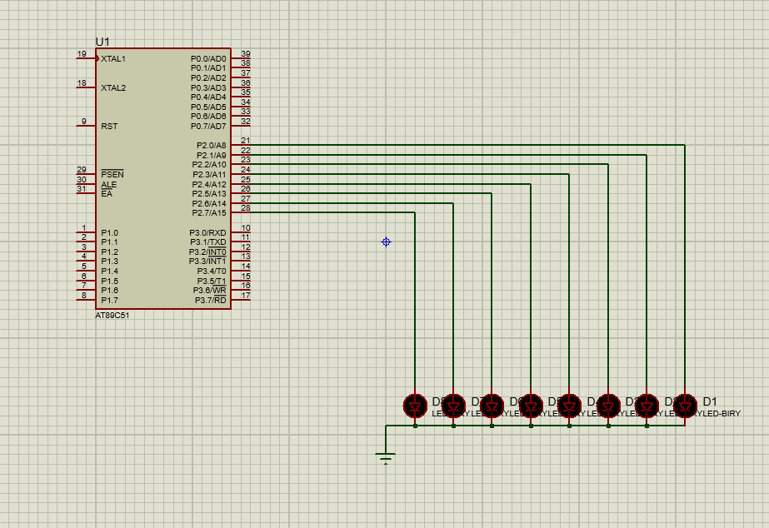
Diagram:

